

D.A.V. PUBLIC School

POWER GRID CAMPUS, BIHAR SHARIF (NALANDA)

(Affiliated to CBSE, New Delhi up to +2 Level)

**Home Assignment for Durga Puja (2025-2026) Class IX**

**ENGLISH**

1. Write a letter to Editor on any topic.
2. Write descriptive paragraph on any one topic.
3. Prepare a project work on ‘Intolerance’

**MATHS**

Solve exercise no. i) 2.3 ii) 6.2 iii) 7.2 from NCERT Book

**S.SC**

**Geography**

1. .Read and remember ch-4 ‘climate?
2. Prepare MCQ and inside questions from this chapter.
3. On an outline map of India show the

[a] Area receiving rainfall over 400 cm.

[b] Area receiving rainfall less than 20 cm.

[c] The place receiving rainfall two times ( Coromondal coast).

[d] The direction of the south –west monsoon over India.

**Civics**-

1. Prepare MCQ from ch-3 ‘electrol plitics’
2. Read ch-4 ‘working of institiutions’

**Economics**

Read Chapter 3

**History**

1. If you were the government of India in 1862 and responsible for supplying the railways with slippers and fuel on such a large scale, what are the steps you would take.
2. Have there been changes in forest area where you live? Find out what these changes are and why they have happened?

**HINDI**

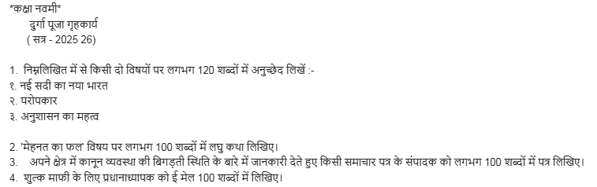

**ICT**

1. Write any four self –management skills.
2. Write steps to insert a table 3x4 in writer and enter any festival related date.

**Note: All students will do their Durga Puja holiday homework in their computer fair copy.**

**SANSKRIT**

**______**

**SCIECNE**

**Physics:**

1. Solve the question paper of Half Yearly Examination of Physics.

2. Distinguish between:

(a) ‘G’ and ‘g’ (b) Mass and Weight (c) Thrust and Pressure

3. State the conditions of ‘Buoyancy’

4. State ‘Archimedies Principle’. How can it be verified?

**Chemistry:-**

1. Write the chemical formula of at least 30 compounds using positive and negative radicals given in your book with their chemical name and the atomicity.

2. Define the following term with an example-

[a] Sublimation [b] Colloid [c] suspension [d] Tyndal effect [e] Concentration [f] Saturated solution [g] Unsaturated solution [h] evaporation [i] Boiling point.

3. Differentaite between

[a] Evaopration and boiling

[b] Compound and mixture

[c] Solution and suspension

4. Name the solute and solvent present

[a] Soda water

[b] tincture of iodine

[c] Bronze

[d] Air

**(Biology)**

1. Draw any one of the following diagrams on a chart paper:-

[a] Fig. 6.9. ch-6 [b] fig. 6.11 ch-6 [c] fig 6.12 ch-6

2. What are semi-autonomous cell organelles?

3. How does plant tissue differ from animal tissues?

4. Write two places where these tissues are found:- [a] Parenchyma [b] Collenchyma [c] Sclerenchyma

5. Differentiate between mitosis and meiosis.

6. What are vascular bundles? Differentiate between xylem and phloem.